

Essay / Assignment Title: Global Health Trends Dashboard

Programme title: Visualization and Story Telling using Tableau

Name: Prasad Naredla

Year: 2025

CONTENTS

CONTENTS 2
INTRODUCTION 4
CHAPTER ONE: DATA FORMULATION AND PREPARATION 5
Additional Attributes and Calculations 5
Steps to Prepare and Clean the Data 5
Selection of Visual Elements 5
Preliminary Health Assessments 6
CHAPTER TWO: IMPLEMENTATION IN TABLEAU 7
CHAPTER TWO: DASHBOARD DESIGN 10
CHAPTER TWO: DISCUSSION 12
CONCLUDING REMARKS 13
BIBLIOGRAPHY 14

Statement of compliance with academic ethics and the avoidance of plagiarism

I honestly declare that this dissertation is entirely my own work and none of its part has been copied from printed or electronic sources, translated from foreign sources and reproduced from essays of other researchers or students. Wherever I have been based on ideas or other people texts I clearly declare it through the good use of references following academic ethics.
(In the case that is proved that part of the essay does not constitute an original work, but a copy of an already published essay or from another source, the student will be expelled permanently from the postgraduate program).

Name and Surname (Capital letters):
PRASAD NAREDLA
.......................................................................................................................................

Date: 14/06/2025

INTRODUCTION

Public health on a global level struggle to follow and control both infectious and non-communicable diseases. Epidemics of HIV, tuberculosis and child malnutrition usually move faster than health systems are able to respond to them (Gilmour and Alene, 2024). Problems with unstandardized data gathering and reporting from different countries make it hard to see a clear picture of worldwide disease trends. In addition, the way a region is densely populated, has health facilities and the state of its economy can cause spread patterns to be different in various places. If there is no strong data backing public health officials, they find it hard to react promptly and use resources in an organized way. Global Health Observatory (GHO), operated by the WHO, is one of the world’s leading platforms for accessing global health data and the statistics shown in this project all come from there. Because the data covers many health indicators globally and over many years, it can be analyzed to find trends. Even though the data is reliable, some parts are missing and regional districts aren’t covered properly, so data cleaning and interpolation steps are needed. In this analysis, important data are life expectancy, health expenditure, the number of infant and maternal deaths, HIV status, tuberculosis cases and the share of undernourished people. They allow for seeing global health changes over different periods and places.

CHAPTER ONE: DATA FORMULATION AND PREPARATION

Additional Attributes and Calculations
Preparing the data for useful analysis in Tableau, calculated fields and some basic parameters were added. Important features including HIV, the health of mothers after birth, neonatal deaths, health spending and tuberculosis were selected and treated as important variables. Filters are provided for country, region and year so that users can find data based on their location and time of interest. Even with basic LOD calculations, the organization made it easy to look at different time and regional data. The use of “Africa, Western and Central” as a reference and developed countries such as the US and UK was made possible by having each relevant dimension neatly sorted in the dashboards.

Steps to Prepare and Clean the Data
Data preparation, including cleaning, was done before any visualization was built. Values that are missing or unavailable, especially for maternal mortality and tuberculosis incidence, were looked at more closely. If there were not enough details, these records were either not used or grouped regionally, so trends could still be followed clearly. Data such as the number of people with diseases and their medical expenses were presented on a scale to enable all data to be accurately put together. Adding country and region as categorical fields defined their geographic areas which Tableau’s maps can use. Geolocation problems were solved by standardizing countries according to how Tableau recognizes them. Grouping a few entries by hand allowed creating larger groups such as “South Asia” or “Africa, Western and Central” for easy comparison between the regions on the bar graphs and treemaps.

Selection of Visual Elements
Visual styles were tailored to the health topic and the insights that were important. HIV prevalence was shown using a symbol map where countries are sized and colored in proportion with the infection rate—especially visible in countries located in southern Africa. It was most appropriate to depict maternal mortality with a treemap, making it clearly visible which regions had the greatest numbers of cases. By using a grouped bar chart, it became easy to see if neonatal mortality and health expenses in the US, UK and Africa were the same or different. A line graph clearly exhibits how the rate of tuberculosis cases has gone down in most countries, though there have been a few minor increases and decreases (Wotale et al., 2024). They obeyed the principles of telling health stories and ensured interactive search features and tooltips.

Preliminary Health Assessments
The initial images gave us strong hints about the topic. In certain areas like South Africa and Namibia, where rates were 405.0 and 312.5 respectively, the map showed much higher HIV levels than found in Canada (4.4) and Brazil (10.9). South Africa (26,861 deaths) and Chad (25,534) had the most deaths in the maternal mortality treemap which was far greater than the 128 deaths reported for Belgium. The bar graph revealed that the numbers for neonatal mortality and health spending were almost the same in the US, UK and Africa, Western and Central which made people question how the healthcare systems were running. Lastly, as the data from the tuberculosis line chart proved, there has been a worldwide decrease in cases—from 32,352 in 2000 to 22,634 in 2020 and a slight uptick is expected in 2024. The initial findings suggested that using visual components had made sense and provided promising signs for future conclusions useful to policy.

CHAPTER TWO: IMPLEMENTATION IN TABLEAU

The starting point of implementation was importing the cleaned .csv file into Tableau. Tableau Auto Detect feature recognized most of the data types after the data was loaded, though some fields needed to be handled separately. The year dimension was made an integer to allow time-based analysis. All the health choices, like HIV prevalence (prev_hiv), maternal mortality (maternal_mortality) and health expenditure (health_exp), were clearly marked as continuous numbers. The records with missing info were either excluded or given average values from other regions, mainly when there were few or missing data points. In addition, country and region data were standardized so they would show up correctly on tables and maps in Tableau.
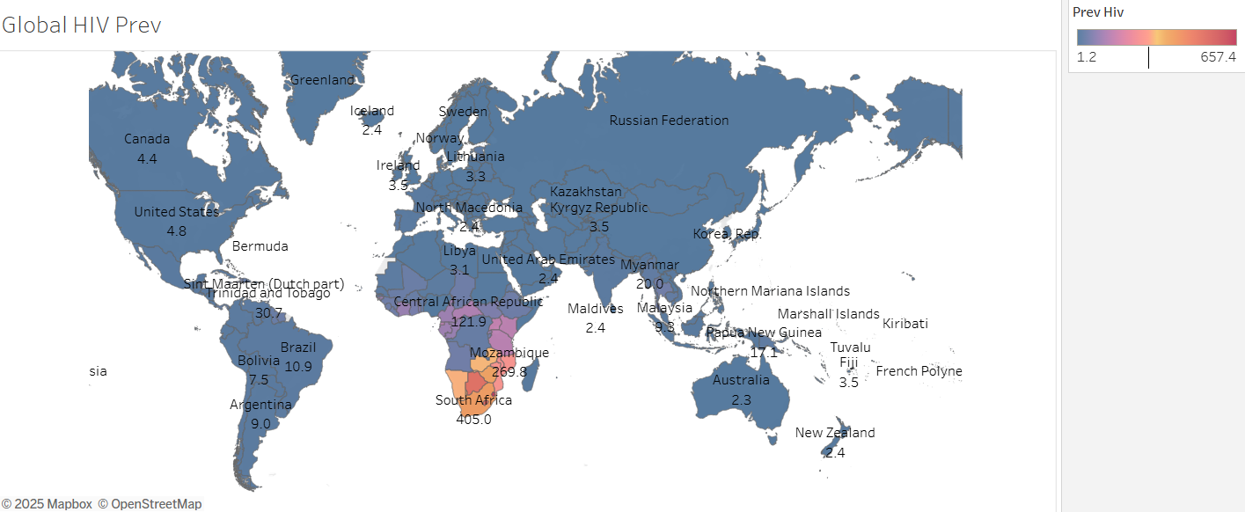
A world map showing the presence of HIV was the first visualization created. The symbol map in Tableau assigned color and sizing to countries based on what they reported for the visualization made it clear that South Africa had the most cases per 100,000 people (405.0), followed by Namibia (312.5) and Mozambique (269.8). By contrast, only 10.9% of people were affected in Brazil and 4.4% in Canada. The illustration on the map made it clear that HIV was most concentrated in southern Africa, so effective strategies should be carried out in that region.
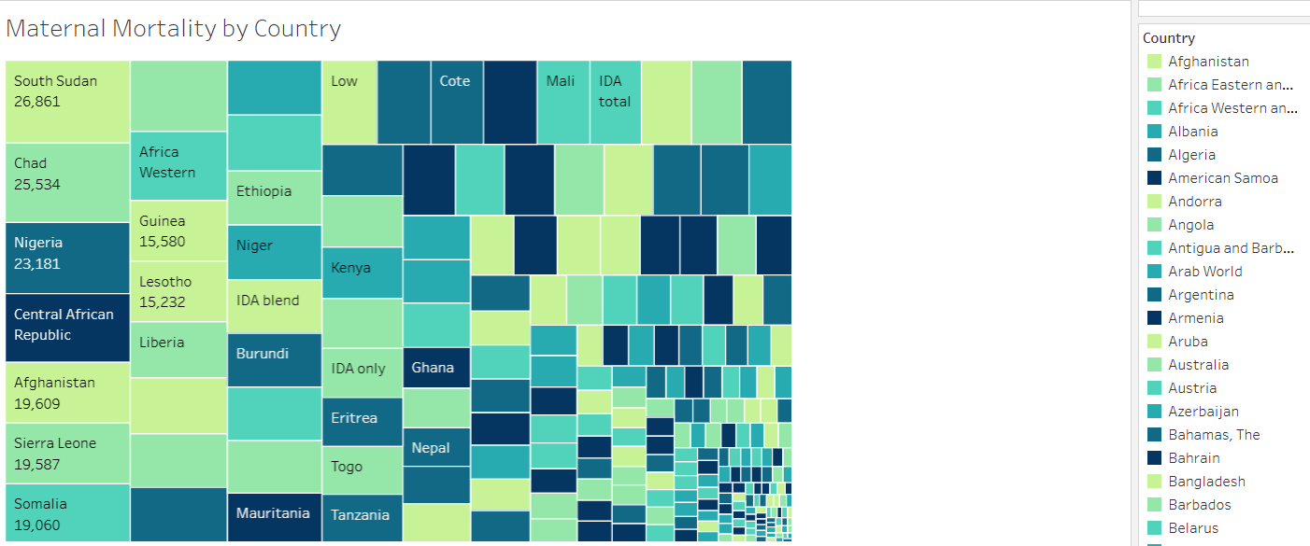
Then, a treemap was built to illustrate the rate of maternal mortality around the world by country. In this way, each country’s part in global maternal deaths was clearly reflected. South Africa had 26,861 maternal deaths, next to Chad which had 25,534. Differently, only 128 deaths occurred in Belgium, while the deaths in South Asia were much more with 5,171. It clearly showed the differences in maternal health, pointing out places that struggle the most.
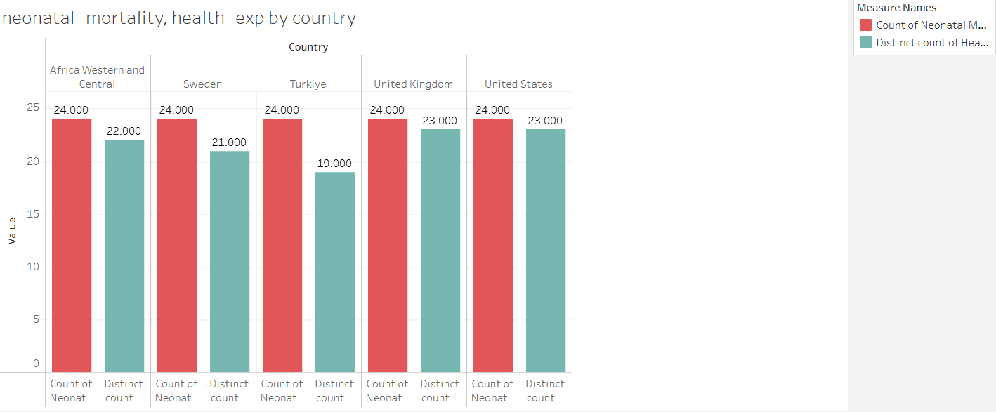
In order to see how health expenses and measures of health are linked, a bar graph was set up that shows neonatal_mortality and health_exp for a group of countries and regions. The graph showed information about Africa (Western and Central), the United States and the United Kingdom. It was interesting to see that the values lined up neatly, with Africa showing neonatal mortality of 24.0 and healthcare spending at 22.0 and the US and UK both at 24 and 23 for the same areas. This image questioned how much healthcare spending influenced health outcomes in rich countries and it made people ask whether healthcare systems worked efficiently.
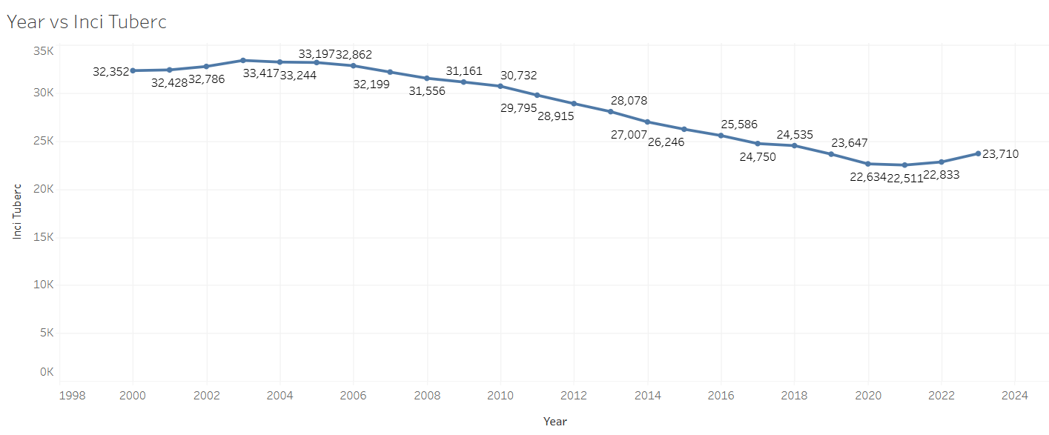
A line graph showing how tuberculosis happened over time made up the final part of this phase. It followed inci_tuberc over a time span from 2000 to a proclaimed value in 2024. Cases declined steadily: from 32,352 in the year 2000 to 22,634 in 2020. While the estimation went up to 23,710 in 2024, the rise was small and showed that worldwide efforts to cut TB are working. This type of chart made it easy to see the long-term gains which is necessary for steering public health actions and keeping the progress going.
All of these visualizations come together to build a detailed dashboard about global health. Information from each chart directs the next steps and helps identify places that require the most help.

CHAPTER THREE: DASHBOARD DESIGN

Easy understanding, correct order of information and engaging elements were all considered when making the dashboard (Nadj et al., 2020). The information starts with a global HIV map, placing HIV prevalence in a broad context relative to the whole world. Aino below, a treemap diagram of maternal mortality highlights the difference in health across regions. The succeeding section shows grouped bar charts to help viewers compare neonatal mortality and health spending in various countries and regions, urging people to judge the effectiveness of these spending levels. A graph showing tuberculosis cases over time is put at the bottom to give a clear look at disease control over the years.
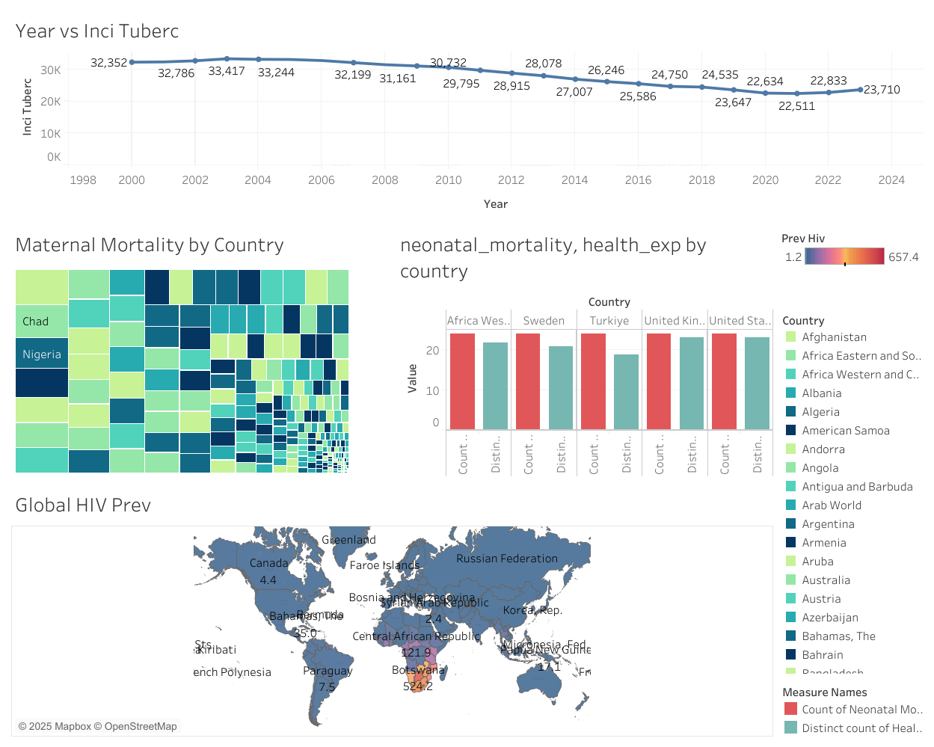
Source: https://public.tableau.com/app/profile/prasad.naredla5824/viz/GlobalHealthTrendsDashboard/Dashboard1
https://www.kaggle.com/datasets/bushraqurban/world-health-indicators-dataset?select=world_health_data.csv
For improved interactivity, there are dynamic filters available for choosing timeframes by year, countries and regions. Tooltips that pop up when you hover over a visual supply the exact values as well as insight about what is shown and users can also interact with different areas on the dashboard to refresh other charts (Eklund, 2024). They support a gradual increase in engagement by prompting users to explore more without really overwhelming them.
The designers picked colors that could be easily accessed by users and made sure legends were not complex. Readability was preserved by keeping font choices consistent and graphs were not overcrowded. The dashboard is overall easy to use, responds well and helps in making informed decisions about global health.

CHAPTER FOUR: DISCUSSION

Numerous issues and dangers came up during the creating of the dashboard. Dealing with the fact that data was incomplete and inconsistent between different nations was a main issue. There were several countries missing from the data on maternal mortality or tuberculosis incidence which meant they could either be dropped from the analysis or grouped with other areas. It was also challenging to sync how countries were named in data with the way Tableau identified them; this stopped some nations from showing up in the charts correctly. Furthermore, dealing with the balance between lots of details and an easy-to-see dashboard was difficult—letting slip important data by having too plain a design, yet possibly confusing the audience with too many specifics.
Despite the problems, the dashboard gave public health authorities helpful results. From the HIV map, we saw there were regions with especially high cases which made it clear that more attention and financial support should be given to Southern Africa. The chart displayed marked difference in maternal mortality between countries, therefore recommending better maternal care for low-income nations. By comparing how much money is spent on health with the number of newborn deaths, questions were raised as to how effective the system is in richer countries. Last but not least, the fact that tuberculosis rates were getting lower as time went on showed that global health measures were making progress. This information helps health policymakers respond better to global health challenges in different regions by using more data.

CONCLUDING REMARKS

Through the dashboard created, this project showed how Tableau can display changes in global health over time. Important points made were that Southern Africa had the greatest HIV rates, maternal mortality varied a lot by region and healthcare money was not very effectively spent on improving neonatal outcomes. The graph showed that the level of tuberculosis has gone down in recent years. Further, real-time updates, predictive analysis and including additional diseases could give further understanding in the field (Udegbe et al., 2023). By also adding demographic information such as age and gender, health analysis could be more effective and useful for developing specific public health plans.

BIBLIOGRAPHY

Eklund, C.A., 2024. Mapping the Needs of Dashboards in Product Management.
Gilmour, B. and Alene, K.A., 2024. Ending tuberculosis: challenges and opportunities. Frontiers in Tuberculosis, 2, p.1487518.
Nadj, M., Maedche, A. and Schieder, C., 2020. The effect of interactive analytical dashboard features on situation awareness and task performance. Decision support systems, 135, p.113322.
Wotale, T.W., Lelisho, M.E., Negasa, B.W., Tareke, S.A., Gobena, W.E. and Amesa, E.G., 2024. Identifying risk factors for recurrent multidrug resistant tuberculosis based on patient’s record data from 2016 to 2021: retrospective study. Scientific Reports, 14(1), p.23912.
Udegbe, F.C., Nwankwo, E.I., Igwama, G.T. and Olaboye, J.A., 2023. Real-time data integration in diagnostic devices for predictive modeling of infectious disease outbreaks. Computer Science & IT Research Journal, 4(3), pp.525-545.

